CENTENNIAL COLLEGE
COMP 397: WEB GAME PROGRAMMING
Project Part One: WebGL Game - GDD V1 - Level Sketch
DUE DATE: May 19, 2025 11:59PM



Polyguns
Version #1

Student: Naomi Mendoza – 301292515
Supervisor: Prof. Alireza Moghaddam

All work Copyright © 2025 by ղąցìղì from ANKASOFT Games.
All rights reserved.

2025/05/13

TABLE OF CONTENTS
VERSION HISTORY 3
I. GAME OVERVIEW 4
II. GAME PLAY MECHANICS 4
III. CAMERA 6
IV. CONTROLS 6
Player: 6
V. GAME SKETCH 6
VI. MENU AND SCREEN DESCRIPTIONS 7
VII. GAME WORLD 8
VIII. LEVELS 8
IX. GAME PROGRESSION 9
X. CHARACTERS 9
XI. WEAPONS 9
XII. ITEMS 10
XIII. ABILITIES 10
XIV. SCORING 10
XV. SOUND EFFECTS AND MUSIC 10
XVI. GAME ASSETS AND MULTIMEDIA 10
XVII. DESIGN NOTES 10
XVIII. FUTURE FEATURES 10

VERSION HISTORY
Version alpha Date Created: TBD
Version beta Date Created: TBD
Version final Date Created: TBD

I. GAME OVERVIEW

Working Title: Polyguns

Genre: Casual One-Player Shooter Game

Target Audience: General audiences – ideal for fans of arcade shooters, casual mobile gamers, and people who enjoy fast-paced reflex-based games.

Scope: This is a 12-week solo development project using Unity 3D. The core gameplay features the player starting as a triangle that evolves into more complex polygons over time.

Platform: Mobile (portrait orientation, 9:16 aspect ratio)

Game Style: Retro-inspired minimalist design with geometric shapes and neon-style VFX.

Unique Concepts:

- Geometry-Based Combat: Damage and health are directly tied to the number of polygon sides—strategic shape evolution and enemy prioritization required. Reinforcing and educational side of polygons to gamers.

- Minimalist Visual Style: Clean, aesthetic optimized for quick, satisfying mobile play.

- Shape vs. Shape Mechanics: Every bullet and enemy is a geometric entity—no traditional characters, only combat by design.

II. GAME PLAY MECHANICS
The gameplay mechanics of Polyguns are designed around strategic shooting, movement, and geometric progression. The player controls a polygonal ship starting as a triangle, navigating the screen in a top-down arcade-style shooter format. Enemies fall from the top of the screen, and the player must shoot them down using bullets with polygon shapes that correlate to damage.

Game Progression:

• Start: The player begins the game as a triangle ship with 100 life points and 3 lives. The ship starts at the bottom center of the screen and can move in four directions within the screen bounds.

• Enemy Descent: Polygon-shaped enemies descend from the top of the screen. Each enemy's toughness is determined by the number of sides it has. For example, a triangle enemy has 3 life, a square has 4, and so on.

• Combat Mechanics: The player fires polygonal bullets, with the number of sides representing the damage they deal.

— Example: A triangle bullet (3 sides) deals 3 damage.
— A square enemy (4 sides) hit by a triangle bullet will need
2 shots to be destroyed (4 toughness - 3 damage = 1 remaining).

• Shape Evolution: Defeating enemies grants EXP. Once the EXP bar is full, the player evolves into a new polygon shape with more sides, increasing their health and possibly unlocking new bullet types.

• Movement: The player can move left, right, up, and down within the screen boundaries. Dodging incoming bullets and positioning strategically are essential for survival.

• Bullet Types:
— Starter Bullet: Diamond (4 sides), deals 4 damage
— Upgrades: Bullets evolve with power-ups or player evolution
into more complex shapes (pentagon, hexagon, etc.)

• Power-Ups and Items: Special items may drop from defeated enemies, allowing temporary boosts like faster shooting, invincibility, or bullet upgrades.

• Round End / Game Over:
— A wave ends when all enemies are cleared or the player is destroyed.
— The game ends when all 3 lives are lost.

• Victory Condition: The goal is to survive progressive waves of increasingly tough enemies. Boss shapes may appear at milestones, requiring advanced bullets and tactics to defeat.

III. CAMERA
A fixed top-down camera view is utilized in Polyguns. The camera remains stationary to provide a clear and consistent view of the vertical gameplay area where enemy polygons descend from the top of the screen. The visible camera area defines the player's movement boundaries and the active play zone.

IV. CONTROLS
[ Mobile Controls]

Player
On-screen joystick for movement.
Auto-fire bullets.
Tap or swipe buttons for activating power-ups or abilities

V. GAME SKETCH
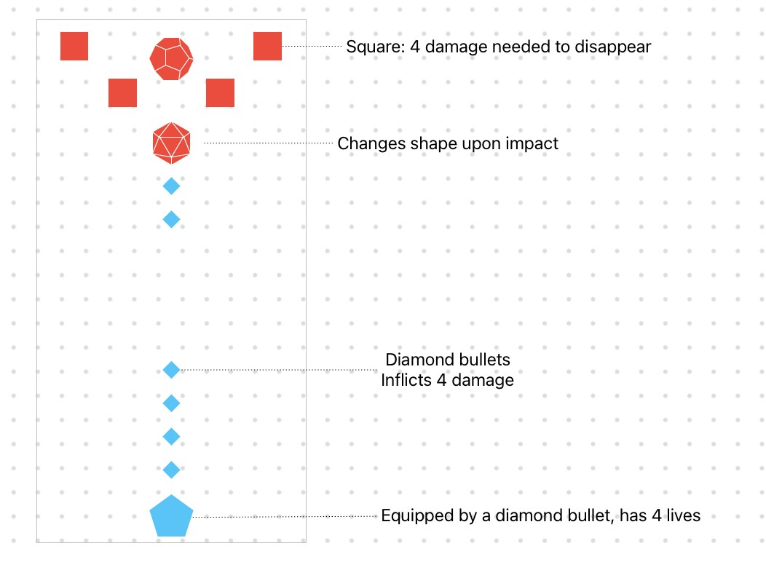

VI. MENU AND SCREEN DESCRIPTIONS

MAIN MENU Screen:

Includes buttons for:

Start – Begins a new game session and transitions to gameplay.

Upgrades – Opens the upgrade menu where players can view their progression and unlock new shapes or bullet enhancements.

Options – Opens the options menu for volume and gameplay settings.

Credits – Displays a screen with acknowledgments to the developers and contributors of the game.

PLAYER STATS Screen:
This screen is accessible from the MAIN MENU or after each completed round.
Displays the player's current ship shape and details:
EXP progress toward the next evolution.

Shows a visual preview of the next polygonal ship shape.

Indicates the required EXP for the next upgrade.

Displays bullet upgrade options unlocked through gameplay progression or pickups.

In-Game PAUSE Screen (ESC button):
The pause screen ensures that game progress is preserved unless the player chooses to restart or quit.
Freezes the game and overlays a pause window with the following options:

Resume – Returns to the game from where it was paused.

Restart – Restarts the current round.

Quit – Returns the player to the MAIN MENU screen.

GAME OVER Screen:
Shown when the player loses all lives or completes the final level. Displays the player's final score and shape level reached.

Includes Retry button to restart the game from the beginning.

Includes Return to Menu button to go back to the MAIN MENU.

VII. GAME WORLD
Defend the cosmic plane from invading shapes!
You are the last-standing geometric defender in a vast abstract zone of dynamic space backgrounds. Enemy polygons rain down in endless waves, increasing in complexity and toughness with each level. From simple circles to massive boss dodecagons, every shape is a threat to be overcome. Harness your evolving ship and polygonal firepower to protect your domain, unlock new abilities, and conquer the geometric storm.

VIII. LEVELS

Polyguns progress in a seemingly infinite waves or stage-based progression. Every 5 waves includes a mini-boss that represents half completion of each Level. Every 10th wave is a boss level with unique polygon enemies. For this project, I would like to develop these 3 Levels:

Level 1: Flat Grid Space
A minimalist open field in space, with a faint grid background. There's nothing to obstruct movement or bullets. This level serves as the beginner round.

Level 2: Fragmented Orbit
A space environment with broken polygonal debris floating around. The debris acts as partial cover and slows movement.

Level 3: Void Core
A black hole-themed level where gravitational effects slightly curve bullets. High-tier enemies and environmental hazards add extra challenge.

IX. GAME PROGRESSION

Each game begins with the player as a Triangle with 100 life points and 3 lives.

• The player must shoot down incoming polygonal enemies descending from the top of the screen.
• Defeated enemies grant EXP. Once the EXP bar is full, the player evolves into the next polygon shape (Square, Pentagon, etc.).
• Each evolution grants more health and bullet power.
• Every 5 waves introduces a mini-boss.
• Every 10 waves present a major boss.
• If the player's HP reaches 0, they lose a life. Losing all lives ends the game.
• Upon game over, a Game Over screen appears showing Score, Retry, and Return to Menu options.

X. CHARACTERS

Player Ship:
• Evolves from Triangle to Decagon as player progresses.
• Shape determines HP and bullet type.
• Has idle blinking animation when hit, but shape does not change upon damage.

Enemy Ships:
• Appear in various polygon shapes, representing different health tiers.
• Circles = 1 HP, Triangles = 3 HP, Squares = 4 HP, etc.

Boss Ships: are multi-faceted and evolve during battle.

XI. WEAPONS
Default Polygon Bullets:
• Triangle bullet: base projectile with 3 damage.
• Damage equals the number of sides.
Upgraded Weapons:
• Will be noted upon development

XII. ITEMS

• EXP Multiplier: Doubles EXP gained for 10 seconds.
• Health Pack: Restores a portion of HP.
• Shield: Grants temporary invulnerability.
• Bullet Upgrade Pack: Temporarily boosts bullet side count by 1

XIII. ABILITIES

• Shape Evolution: Automatically triggers once EXP bar is full.
• Polygon Blast (Future Feature): Clears all enemies on screen.
• Burst Mode: Temporarily increases firing rate.

XIV. SCORING

• Destroying enemy shapes increases score based on shape toughness.
• Combo kills grant bonus points.
• Boss defeats yield large score boosts.
• Score and EXP are tracked separately.

XV. SOUND EFFECTS AND MUSIC
Will be noted upon development

XVI. GAME ASSETS AND MULTIMEDIA
Will be noted upon development

XVII. DESIGN NOTES
Will be noted upon development

XVIII. FUTURE FEATURES
Will be noted upon development

